**Unit 6**

**AP Macroeconomics – International Trade and Finance**

1. Which of the following best explains why many United States

economists support free international trade?

(A) Workers who lose their jobs can collect unemployment

compensation.

(B) It is more important to reduce world inflation than to reduce

United States unemployment.

(C) Workers are not affected; only businesses suffer.

(D) The long-run gains to consumers and some producers exceed

the losses to other producers.

(E) Government can protect United States industries while

encouraging free trade.

1. If the real interest rate in Country X increases relative to the real interest

rate in Country Y and there are no trade barriers between the two countries, then for country X which of the following will be true of its capital flow, the value of its currency, and its exports?

|  |  |  |  |
| --- | --- | --- | --- |
|  | Capital Flow | Currency | Exports |
|  |  |  |  |
| (A) | Inflow | Appreciation | Increase |
| (B) | Inflow | Appreciation | Decrease |
| (C) | Inflow | Depreciation | Increase |
| (D) | Outflow | Depreciation | Increase |
| (E) | Outflow | Appreciation | Decrease |

1. If a country has a current account deficit, which of the following must be

true?

1. It must also show a deficit in its capital account.
2. It must show a surplus in its capital account.
3. It must increase the purchases of foreign goods and services.

(D) It must increase the domestic interest rates on its bonds.

(E) It must limit the flow of foreign capital investment

1. With an increase in investment demand in the United States, the real interest

rate rises. In this situation, the most likely change in the capital stock of the United States and in the international value of the dollar would be which of the following?

|  |  |  |
| --- | --- | --- |
|  | Capital Stock in United States | International Value of the Dollar |
| (A) | Increase | Decrease |
| (B) | Increase | No change |
| (C) | Increase | Increase |
| (D) | Decrease | Increase |
| (E) | No change | Decrease |

1. Which of the following would cause the United States dollar to increase in

value compared to the Japanese yen?

1. An increase in the money supply in the United States
2. An increase in interest rates in the United States
3. An increase in the United States trade deficit with Japan
4. The United States purchase of gold on the open market
5. The sale of $2 billion dollars worth of Japanese television sets to the United States
6. Assume that the supply of loanable funds increases in Country X. The

international value of Country X’s currency and Country X’s exports will most likely change in which of the following ways?

|  |  |  |
| --- | --- | --- |
|  | International Value of Country X’s Currency | Country X’s  Exports |
| (A) | Decrease | Decrease |
| (B) | Decrease | Increase |
| (C) | Increase | Decrease |
| (D) | Increase | Increase |
| (E) | Not change | Not change |

1. An increase in Japan’s demand for United States goods would cause the

value of the dollar to

1. Depreciate because of inflation
2. Depreciate because the United States would be selling more dollars to Japan
3. Depreciate because the United States money supply would increase as exports rise
4. Appreciate because Japan would be buying more United States dollars
5. Appreciate because Japan would be selling more United States dollars
6. Which of the following changes will occur to the demand for United

States dollars and the international value of the dollar in the short run if investors in the United States and abroad increase their purchases of United States government bonds?

|  |  |  |
| --- | --- | --- |
|  | Demand for Dollars | International Value  of the Dollar |
| (A) | Decrease | Decrease |
| (B) | Decrease | Increase |
| (C) | Decrease | No change |
| (D) | Increase | Decrease |
| (E) | Increase | Increase |

1. As nations specialize in production and trade in international markets, they can expect which of the following domestic improvements?
2. Allocation of domestic resources
3. Standard of living
4. Self-sufficiency
5. I only
6. II only
7. III only
8. I and II only
9. I, II, and III
10. Which of the following would be most likely to occur if the United States

placed high tariffs on imported goods?

1. Workers in the United States would have more jobs in the long run.
2. Income in the United States would be redistributed from the rich to the poor.
3. The United States standard of living would increase.
4. The United States economy would become less efficient.
5. United States exports would increase.

**Answers to 2005 Questions w/Explanation**

1. Which of the following best explains why many United States

economists support free international trade?

(D) The long-run gains to consumers and some producers exceed

the losses to other producers.

**Explanation:** Although free trade creates both winners and losers, the gains from trade outweigh the costs. Free trade allows countries to experience a level of consumption in excess of their level of production. Furthermore, evidence indicates that countries engaging in free trade tend to enjoy a higher standard of living than countries that tend to be more protectionist with regards to trade.

1. If the real interest rate in Country X increases relative to the real interest

rate in Country Y and there are no trade barriers between the two countries, then for country X which of the following will be true of its capital flow, the value of its currency, and its exports?

|  |  |  |  |
| --- | --- | --- | --- |
|  | Capital Flow | Currency | Exports |
| (B) | Inflow | Appreciation | Decrease |

**Explanation:** Country X’s relatively higher real interest rates provides an incentive for financial investors in Country Y to purchase Country X’s financial assets (bonds). This activity creates an inflow to the capital account for Country X. Before Country Y’s financial investors are able to purchase Country X’s financial assets, they must first engage in foreign exchange. To purchase Country X’s financial assets, Country Y’s investors must supply Country Y’s currency and demand Country X’s currency. This causes Country X’s currency to appreciate in value. Exports then decrease because Country X’s appreciated currency makes Country X’s goods and services relatively more expensive.

# LET COUNTRY X’s CURRENCY = $ and COUNTRY Y’s CURRENCY = Y

**Y/$**

**S**

# 

**🡪**

## e1

**↑**

**e**

**D1**

**🡪 D**

**Q Q1  Q$**

1. If a country has a current account deficit, which of the following must be

true?

(B) It must show a surplus in its capital account.

**Explanation:** In the long run, the balance of payments equals zero. Deficits in one account will be offset by surpluses in the other account.

1. With an increase in investment demand in the United States, the real interest

rate rises. In this situation, the most likely change in the capital stock of the United States and in the international value of the dollar would be which of the following?

|  |  |  |
| --- | --- | --- |
|  | Capital Stock in United States | International Value of the Dollar |

|  |  |  |
| --- | --- | --- |
| (C) | Increase | Increase |

**Explanation:** Capital stock increased because of the increase in gross private investment. This occurred because of the increased investment demand. The resulting higher real interest rate provided an incentive for foreign investors to seek higher real rates of return in the United States. This financial investment, in turn, required foreign exchange. Foreigners had to supply their currency and demand dollars in the foreign exchange market, which resulted in an increase in the international value of the dollar. **(FC = Foreign Currency)**

**FC/$**

**S**

# 

**🡪**

## e1

**↑**

**e**

**D1**

**🡪 D**

**Q Q1  Q$**

1. Which of the following would cause the United States dollar to increase in

value compared to the Japanese yen?

(B) An increase in interest rates in the United States

**Explanation:** The higher real interest rate provides an incentive for Japanese investors to seek higher real rates of return in the United States. This financial investment necessitates foreign exchange. The Japanese supply yen and demand dollars in the foreign exchange market, which results in an increase in the value of the dollar relative to the yen (Y).

**Y/$**

**S**

# 

**🡪**

## e1

**↑**

**e**

**D1**

**🡪 D**

**Q Q1  Q$**

1. Assume that the supply of loanable funds increases in Country X. The

international value of Country X’s currency and Country X’s exports will most likely change in which of the following ways?

|  |  |  |
| --- | --- | --- |
|  | International Value of Country X’s Currency | Country X’s  Exports |
| (B) | Decrease | Increase |

**Explanation:** Increased supply of loanable funds will reduce the real interest rate in Country X. X will seek higher returns abroad and supply X’s currency in foreign exchange, which results in the currency depreciating. Exports will then increase because X’s goods and services will be relatively less expensive.

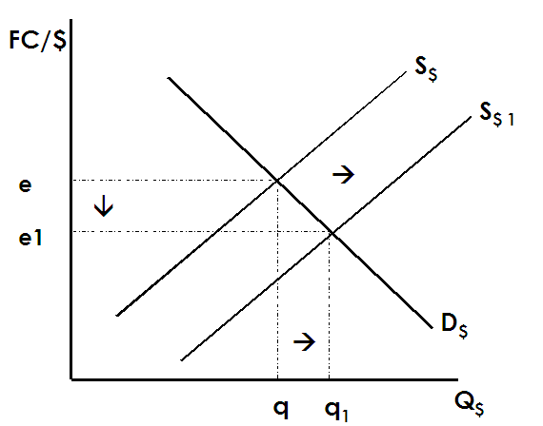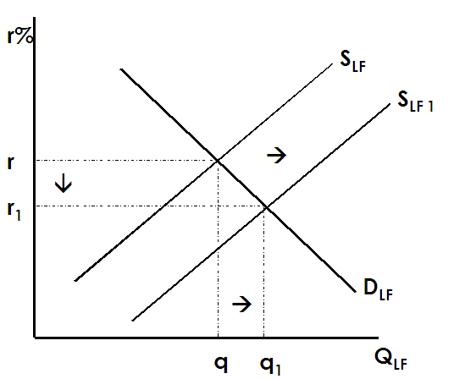

### Answers to 2000 Questions w/Explanation

1. An increase in Japan’s demand for United States goods would cause the

value of the dollar to

1. Appreciate because Japan would be buying more United States

Dollars

**Explanation:** In order for Japanese consumers to purchase American goods, Japanese yen (Y) must be supplied in foreign exchange and American dollars must be demanded. The increased demand for the dollar causes it to appreciate in value.

**Y/$**

**S**

# 

**🡪**

## e1

**↑**

**e**

**D1**

**🡪 D**

**Q Q1  Q$**

1. Which of the following changes will occur to the demand for United

States dollars and the international value of the dollar in the short run if investors in the United States and abroad increase their purchases of United States government bonds?

|  |  |  |
| --- | --- | --- |
|  | Demand for Dollars | International Value  of the Dollar |

|  |  |  |
| --- | --- | --- |
| (E) | Increase | Increase |

**Explanation:** Once again… **FC/$**

**S**

# 

**🡪**

## e1

**↑**

**e**

**D1**

**🡪 D**

**Q Q1  Q$**

1. As nations specialize in production and trade in international markets, they can expect which of the following domestic improvements?
2. Allocation of domestic resources
3. Standard of living
4. Self-sufficiency
   1. I and II only

**Explanation:** When a nation’s people specialize and trade, they can expect increased efficiency in their economy. This results in improved allocation of domestic resources towards their best use and a general increase in the standard of living. With specialization and trade people become more interdependent and less self-sufficient.

1. Which of the following would be most likely to occur if the United States

placed high tariffs on imported goods?

* 1. The United States economy would become less efficient

**Explanation:** High tariffs would protect less efficient domestic producers from foreign competition. As a result, domestic resources that could be put to more efficient use are dedicated to a less efficient purpose.